STReight™
LOTTO 8/8

Dr. Catalin Florian Radut
Dr. Andreea Magdalena Parmena Radut
108 Toamnei St.,
Bucharest, sector 2
020715 Romania
Tel: (+40) 722 302258
Telefax: (+40) 21 2110198
Telefax: (+40) 31 4011654
URL: http://radut.net, http://puzzle.ro, http://streight.co.uk
e-mail: florian@radut.net

Lotto STReight™ 8
(Lotto 8 din 8)

Game summary
To play Lotto 8/8 the players must choose in an ordered fashion any eight Numbers, from 1 to 8, out of eight numbers. Eight numbers are drawn out of eight, one by one, and after each draw, the drawn number is put back into the drawing device. To win the Jackpot, the player must match all the eight Numbers. A seven Numbers match win the second highest prize. Matches of six, five, four, three and two Numbers win smaller prizes.
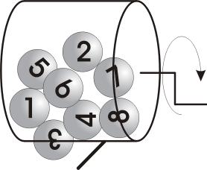
Game description
An electronic /mechanic drawing device with eight balls inside, numbered or labelled with different symbols, and grids used by the players to mark their combinations, made the Lotto STReight™ game. After each draw, the drawn ball is put back into the drawing device, being used for all drawings. The drawn combination forms, sequentially, formations that give the value of the prize.
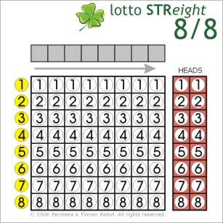
The game grid (ticket)
The grid for marking the gambling combination has a betting zone (white) that is divided in 64 sectors arranged on 8 rows and 8 columns. The numbered sectors (yellow) that represent the numbers for the drawing out marks the rows, and the sequence of played numbers (grey squares) marks the columns.

The players have to mark the equivalent of the chosen numbers in the betting zone (white squares) and may write down the combination in the grey squares, for reference. Consequently, each played number will have a correspondence on a certain row and column.

Next to the betting zone there are two red columns labelled HEADS used to play the first and the last numbers, as an option.

For playing the LOTTO game, the players have to choose an eight Numbers combination and then they have to mark the equivalent of the chosen numbers in the betting zone, so the variant can be red automatically. For a bigger gain, they can play more than one number for each position of the drawn combination. In this case, the filled grid will enclose more combinations. The number of resulting variants (combinations) will be calculated by multiplying the number of chosen Numbers on each white column.

HEADS option
Together with the main game, the players may choose to play the HEADS option meaning the pair(s) of the first and the last numbers which can be different from the pair(s) in the played combination(s). The number of HEADS variants will be given by multiplying the number of chosen Numbers on each red column.

For example, if a player marks two numbers on the left red column (2 and 4) and three on the right red column (1, 2 and 3), there will be 2*3=6 HEADS pairs, as follow: 2-1, 4-1, 2-2, 4-2, 2-3, 4-3.

The payouts
Following the drawing could have been rewarded successively formations from 2 to 8 numbers in accordance with categories I-VII. In case of multiple formations, each of them will win separately. Also, winning combinations on HEADS are separately rewarded.

The prizes categories are:
- I Category – all drawn numbers in the same order;
- II Category – 7 successive numbers;
- III Category – 6 successive numbers;
- IV Category – 5 successive numbers;
- V Category – 4 successive numbers;
- VI Category – 3 successive numbers;
- VII Category – 2 successive numbers;

LOTTO |  |  |  | Prize pool
STReight™ 8/8 |  |  |  |  | Lottery advantage |  | Amount played
 |  |  |  |  | 45% |  | 1,000,000 €
 |  |  |  |  | Total max Prizes |  | Prizes for played amount
 |  |  |  |  | 9,227,469 € |  | 550,000 € | Estimation
Category | Formations | Total winning combinations | Winning combinations percentage | Category prize percentages | Total prizes per categ. | Categ. Prize | Total | Winners | Total Prizes | Prize pool
VII | 2 | 1,507,642 | 8.986247% | 30% | 2,768,241 € | 1.84 € | 165,000 € | 89,862 | 164,999 € | 0 €
VI | 3 | 158,004 | 0.941777% | 8% | 738,198 € | 4.67 € | 44,000 € | 9,417 | 43,996 € | 0 €
V | 4 | 16,577 | 0.098807% | 4% | 369,099 € | 22.27 € | 22,000 € | 988 | 21,999 € | 0 €
IV | 5 | 1,680 | 0.010014% | 3% | 276,824 € | 165 € | 16,500 € | 100 | 16,478 € | 0 €
III | 6 | 161 | 0.000960% | 3% | 276,824 € | 1,719 € | 16,500 € | 9 | 15,475 € | 0 €
II | 7 | 14 | 0.000083% | 12% | 1,107,296 € | 79,092 € | 66,000 € | 0 | 0 € | 66,000 €
I | 8 | 1 | 0.000006% | 40% | 3,690,988 € | 3,690,987 € | 220,000 € | 0 | 0 € | 220,000 €
Combinations |  | 1,684,079 | 10.037893% | 100% | 9,227,469 € |  | 550,000 € | 100,376 | 262,946 € | 286,000 €
16,777,216 |  |  |  |  | * Assumption: one variant cost 1 €.

LOTTO |  |  | “HEADS” Prize pool
STReight™ 8/8 |  |  |  | Lottery advantage |  | Amount played
(heads) |  |  |  | 40% |  | 100,000 €
 |  |  |  | Total max Prizes |  | Prizes for played amount
 |  |  |  | 10,066,330 € |  | 60,000 € | Estimation
Category | Total winning combinations (HEADS) | Winning combinations percentage | Category prize percentages | Total prizes per categ. | Categ. Prize | Total | Winners | Total Prizes | Prize pool
heads + | 262,144 | 1.5625% | 100% | 10,066,330 € | 38.40 € | 60,000 € | 1,562 | 59,981 € | 0 €
Combinations | 262,144 | 1.5625% | 100% | 10,066,330 € |  | 60,000 € | 1,562 | 59,981 € | 0 €
16,777,216 |  |  |  | * Assumption: one variant cost 1 €.

Object of the game
To win at STReight™ the player needs to predict sequentially formations in the drawn combination.

Some players go with the winning formations calling them 'hot' formations and therefore likely to come up more times. Others see which formations did not come up for some time and bet on them believing that their turn is now due. Some players bet on many formations to increase their chances of winning at every deal. Other methodical players use specific STReight™ systems or methods, money management systems, or both.

Game example
It was withdrawn the combination 1-2-1-3-8-6-4-4.



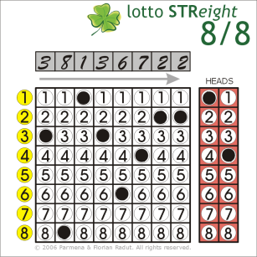
Example 1

One player has bet on 3-8-1-3-6-4-2-2, and plays 1-4 for “HEADS”.

Because 1-3 formation is exactly in the same position as in the drawn combination, the player wins category VII. The ticket has a winning HEADS combination also (1-4).

Yet formations 3-8 and 6-4 appear in the drawn combination those are not in the same position as in the drawn combination and, therefore, have no value.

Example 2

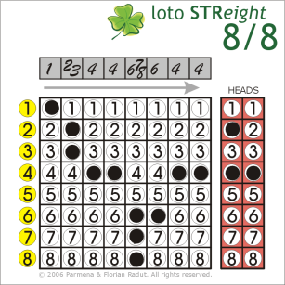
Someone plays 11 numbers in the following succession: 1-23-4-4-678-6-4-4, and three numbers as HEADS.

So, there are 2*3=6 game variants and 2*1=2 HEADS variants:

1-2-4-4-6-6-4-4
1-3-4-4-6-6-4-4
1-2-4-4-7-6-4-4
1-3-4-4-7-6-4-4
1-2-4-4-8-6-4-4
1-3-4-4-8-6-4-4

2-4, 4-4

The grid in the example has the following winning formations:
1-2 wins three times (category VII);
6-4-4 wins four times (category VI);
8-6-4-4 wins two times (category V).

Lotto STReight (Lotto 8/8) Features

- More possible combinations in Lotto 8/8 – 16.777.216 – comparing with other lottery games (e.g. Lotto 6/49);

- Lotto 8/8 allows 8 or more numbers to be played allowing complicated games strategies. Together with the main game, there is a secondary option (HEADS), meaning the pair(s) of the first and the last numbers which can be different from the pair(s) in the played combination(s).

- There are numerous prizes. In fact, 1 of 10 players wins - 10,038% winners at regular STReight and 1,562% at STReight heads.

- The game can be easily implemented on the existing 6/49 machines without any hardware upgrades.

- The game can be easily played by phone/SMS, also.

